**Patterns: pattern_FakeDoc_variety1 identified as layered and non-layered**

**The name of the corresponding sample app is Battery SuperCharger, and the name of the identified app is SMS Scheduler. The main function of the sample app is to send personal information and short message information to the fixed address to steal useful information. The main function of the identified app is to schedule short messages.**

**The main forms of Patterns are as follows:**

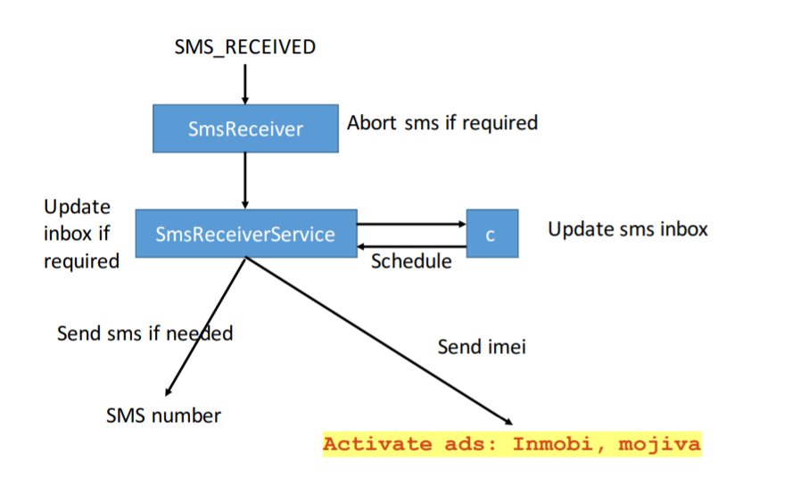

**The key code that belongs to the Patterns corresponds to the function:**

**Next, the key codes in the sample corresponding to each function block are listed. Then the key codes in the sample corresponding to each function block are described in color. Then the key codes in the app are listed. Then the key codes in the app are introduced in function.**

**For modules:**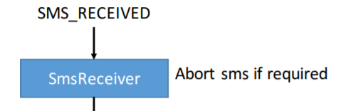

**The main function is to receive short messages.**

**The corresponding key code in sample:**

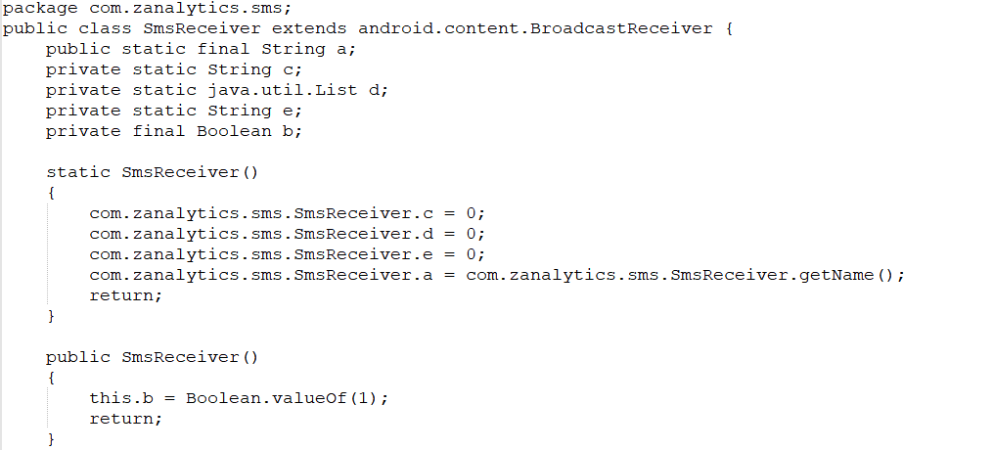

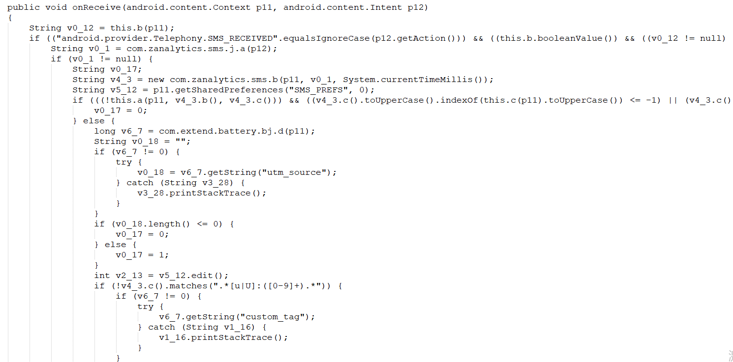

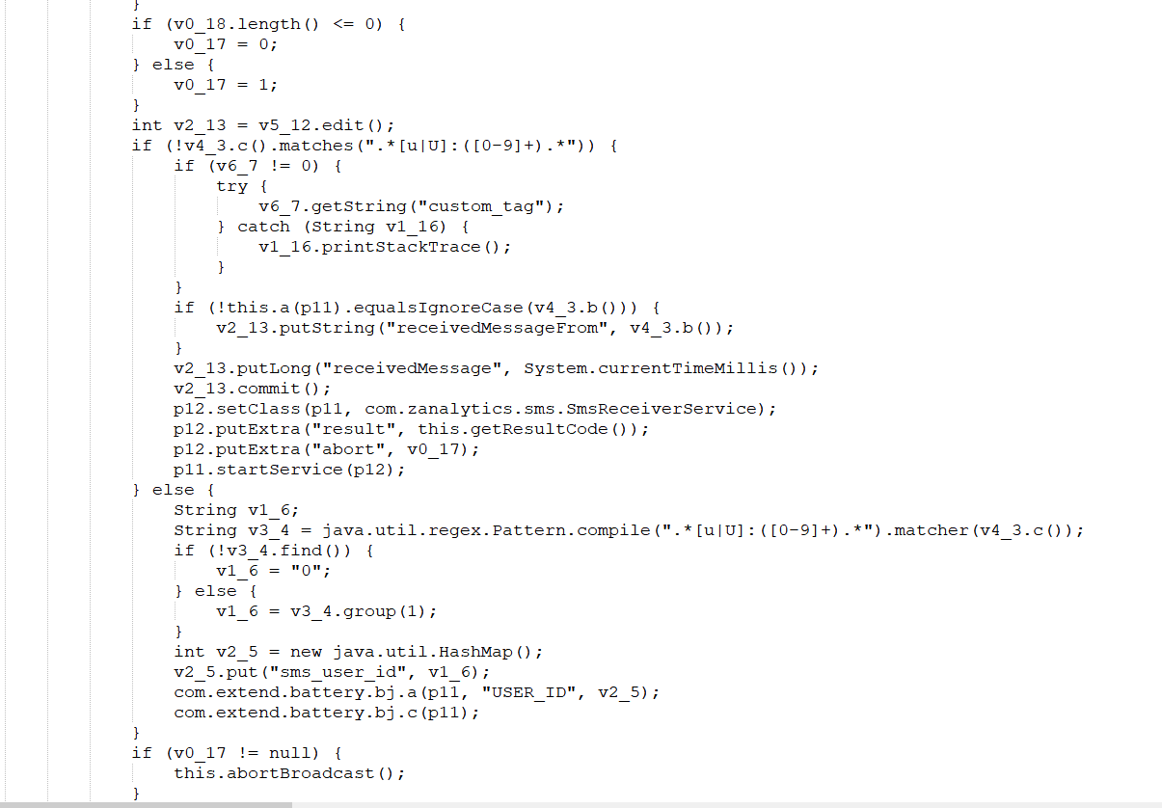

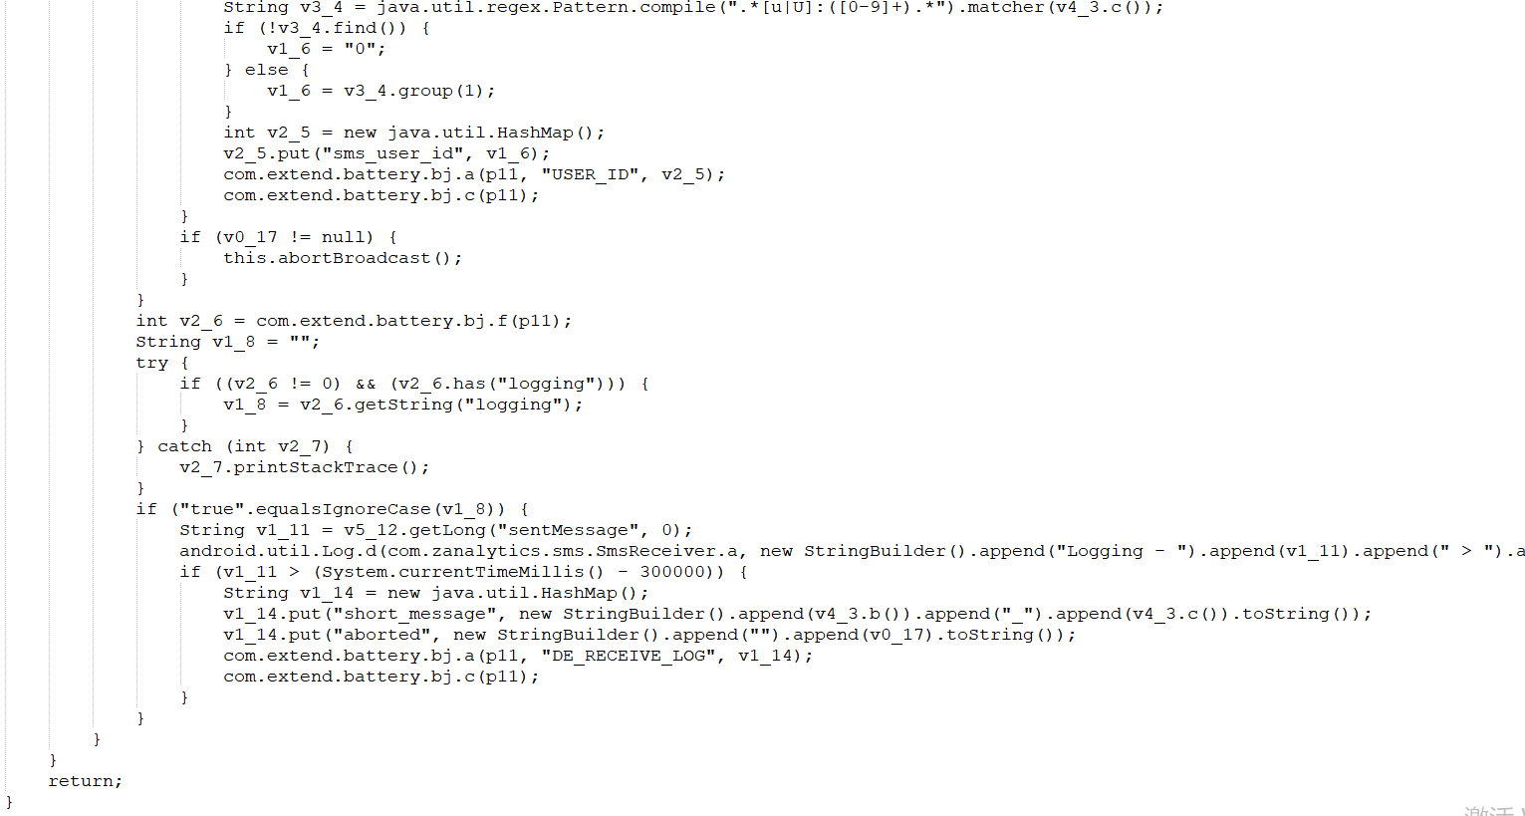

**For the above code, inherit first****Define the broadcasting receiver, and receive short messages by rewriting the broadcasting receiver's total onReceive callback function. When the system receives short messages, it will implement the broadcasting receiver through the action of "android. provider. Telephony. SMS_RECEIVED", and listen to the broadcasting, then it can get short messages.**

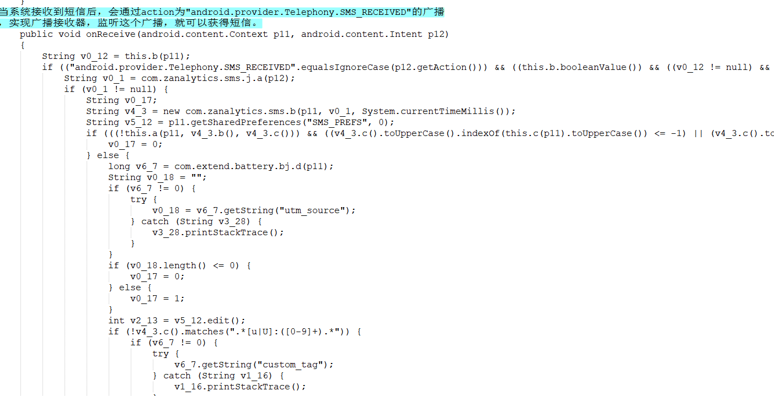

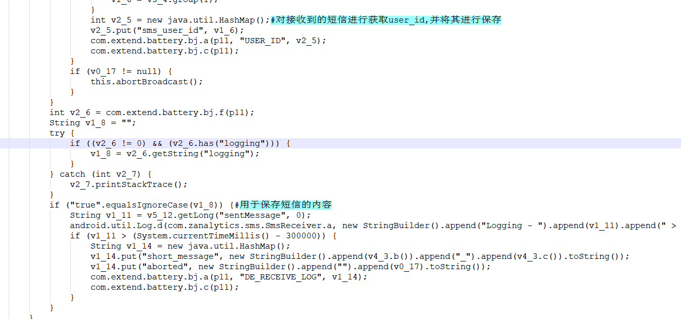

**For the corresponding key code in this app: (this part of the code only corresponds to the callback function and some keywords are similar)**

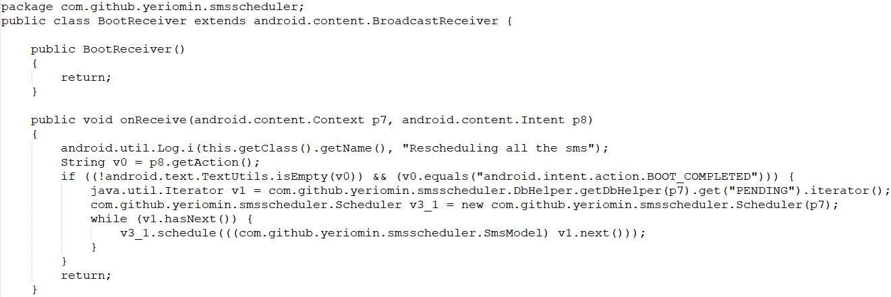

**The main function of this part is to send Android. intent. action. BOOT_COMPLETED broadcasting when the Android phone is turned on. Listening to this broadcasting can monitor the boot. And sample.**

**The corresponding callback function in app is the same as the inherited broadcast receiver, so the callback function and the broadcast receiver keyword match. Within a certain threshold, the two parts are similar.**

**For functional modules:**

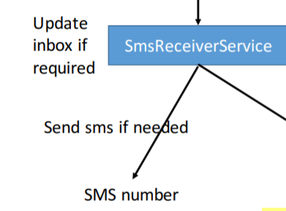

**The main function of this module is to update the inbox if necessary, send short message information and number information of SMS if necessary.**

**Corresponding to the code in sample:**

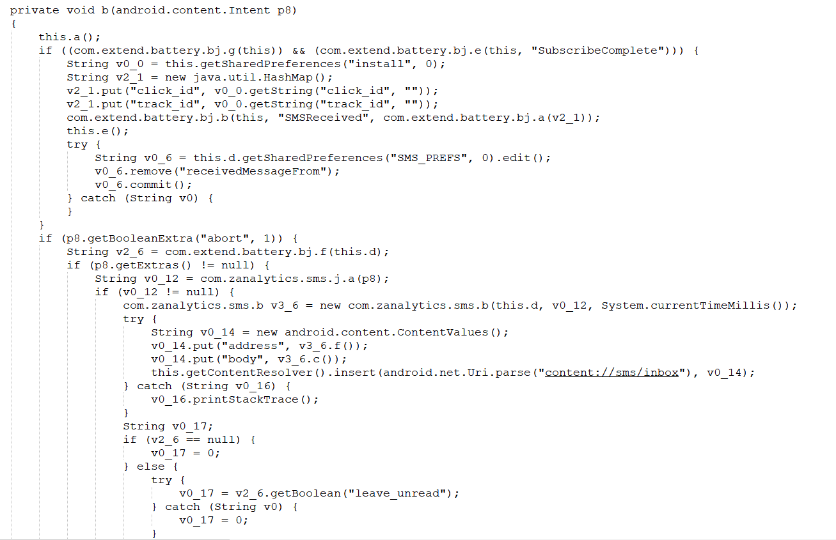

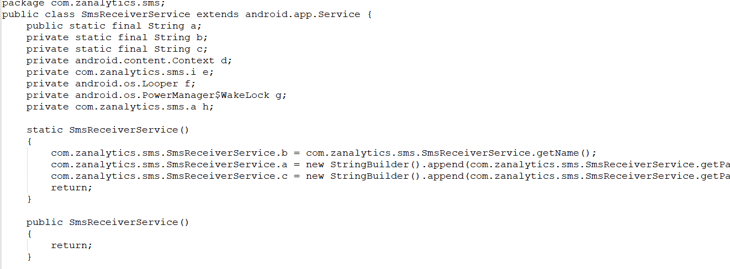

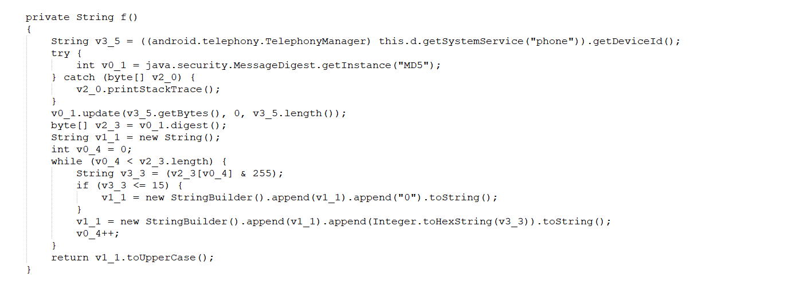

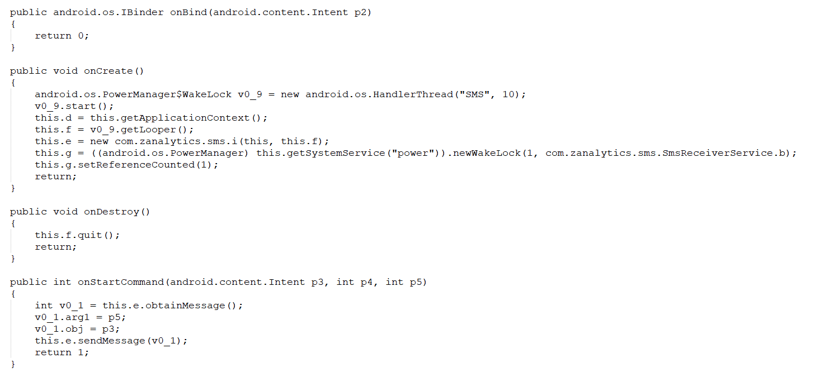

**Main functions:**

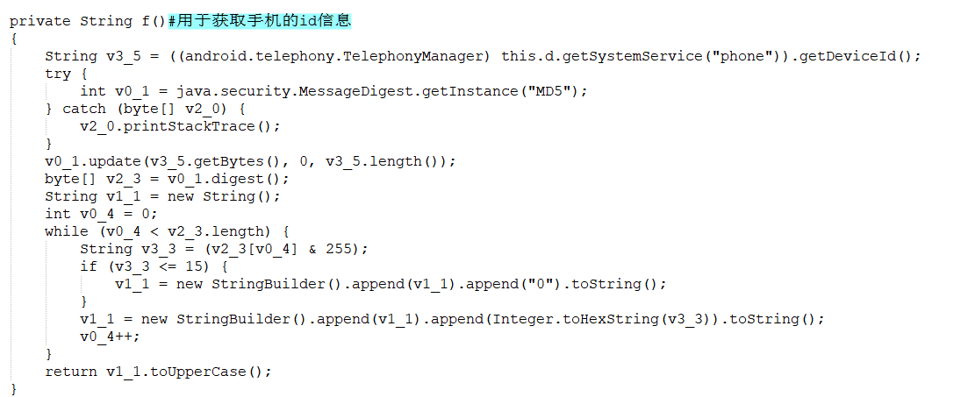

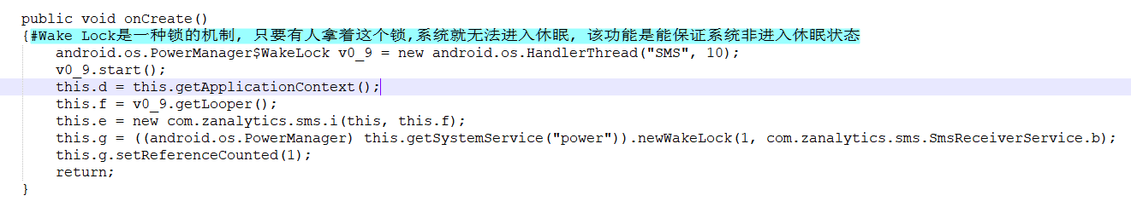

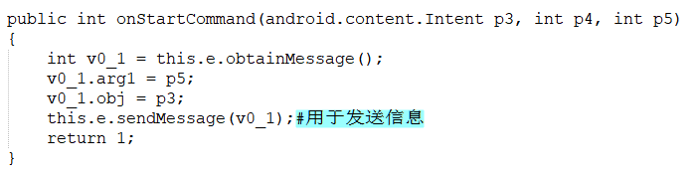

**Corresponding to the code in this app**

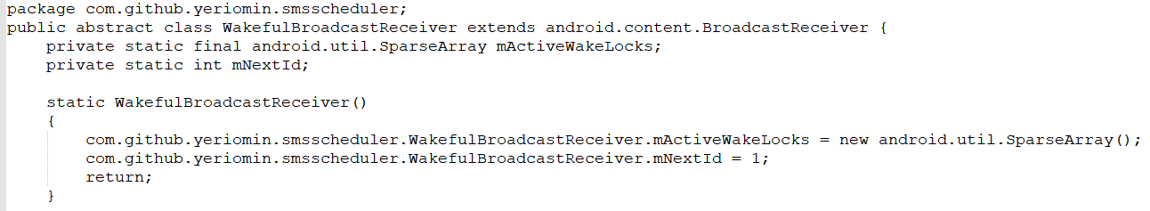

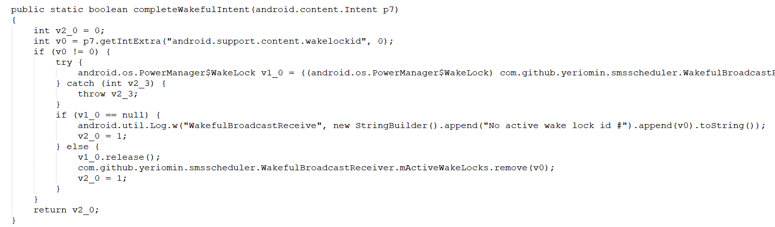

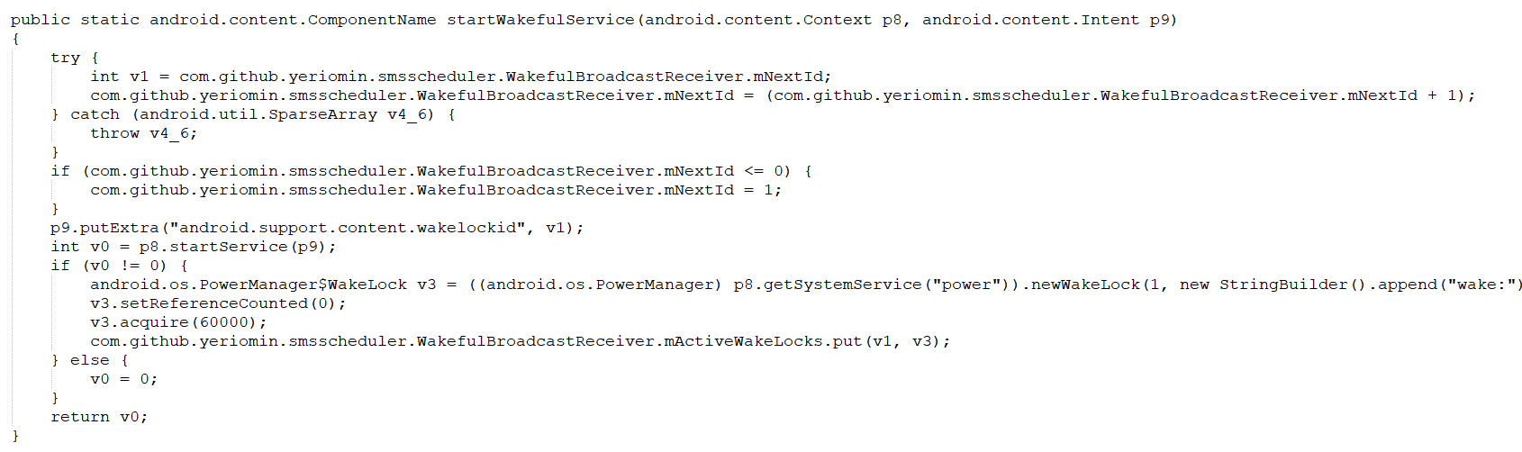

**Introduction to the above functions:**

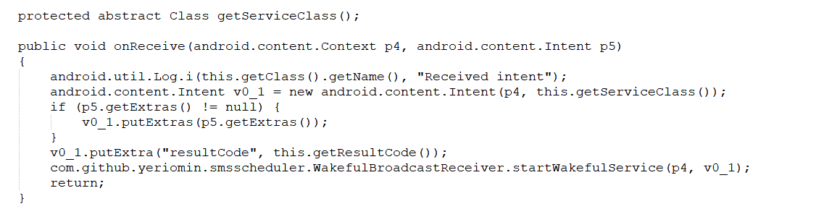

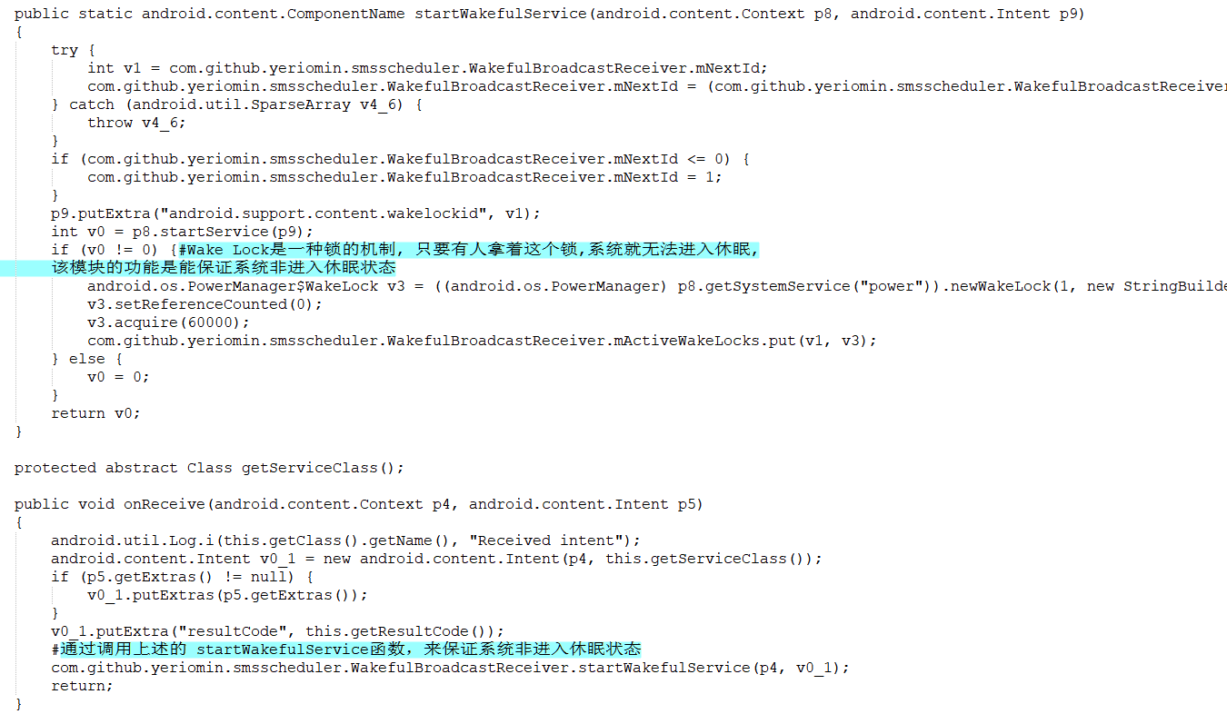

-----------------------------

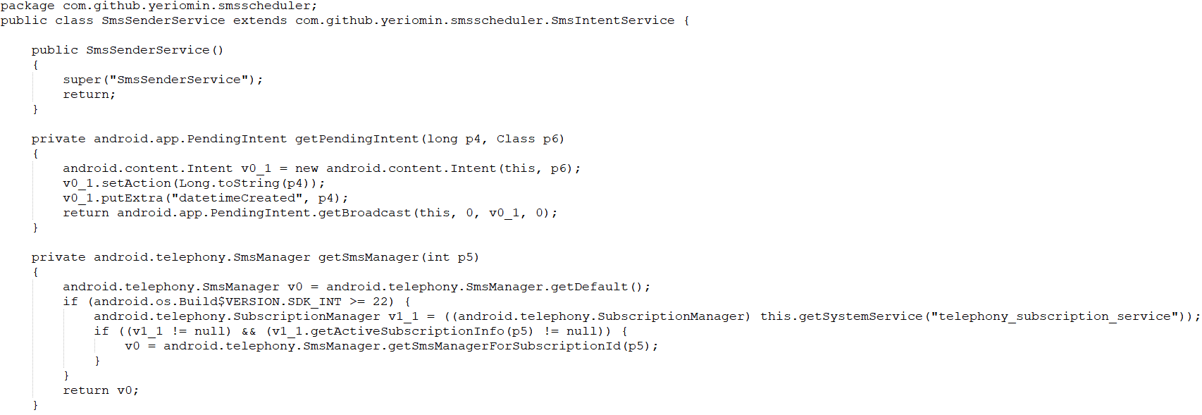

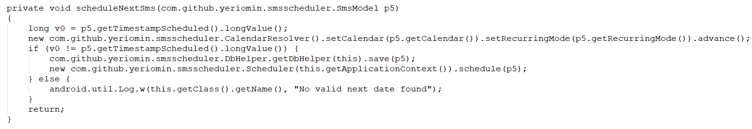

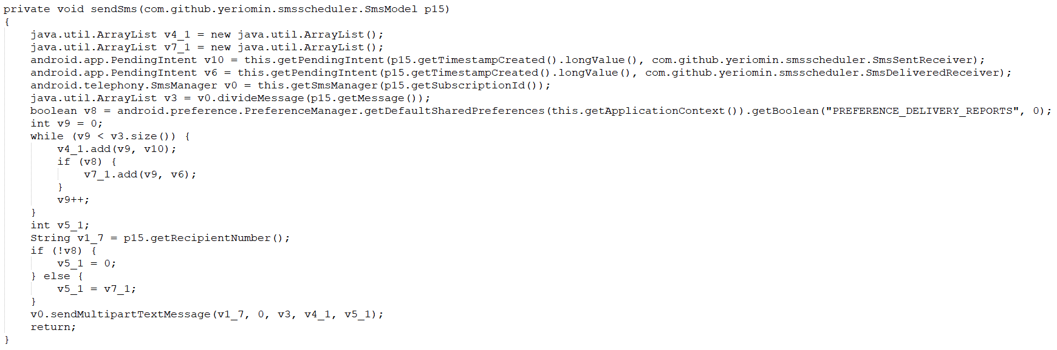

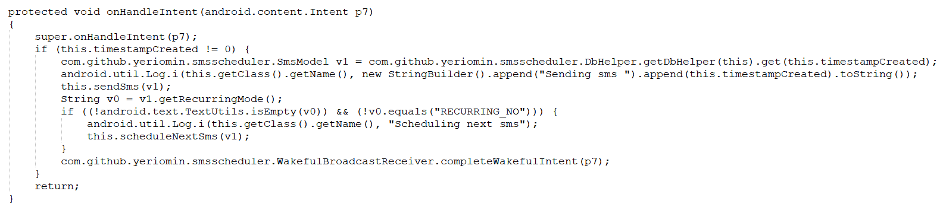

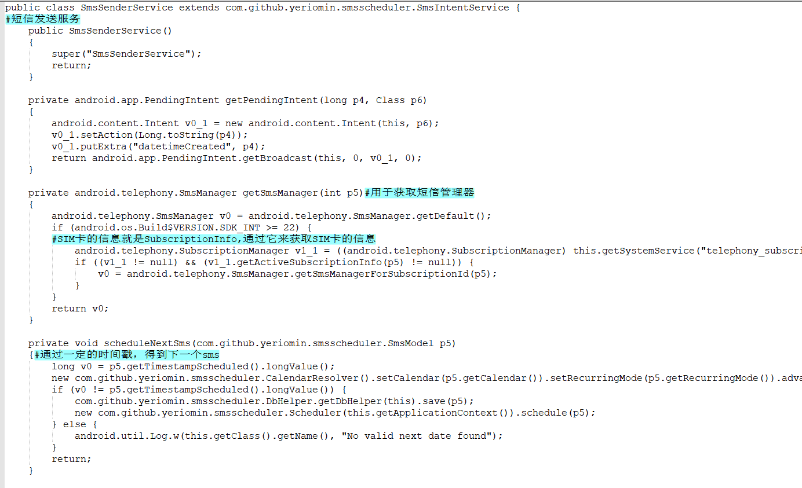

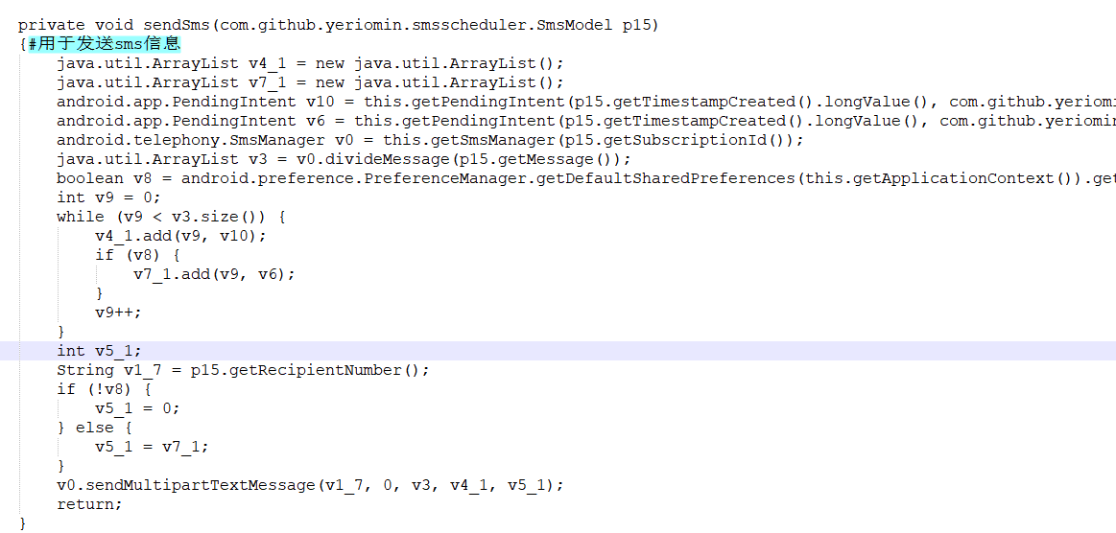

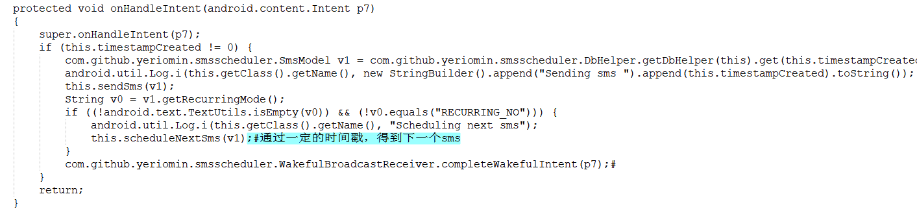

**Introduction to the above functions:**

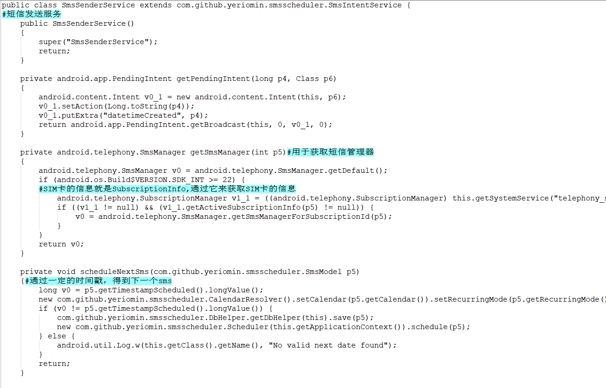

**For the corresponding callback function in the sample above, you can find it by searching in apk**

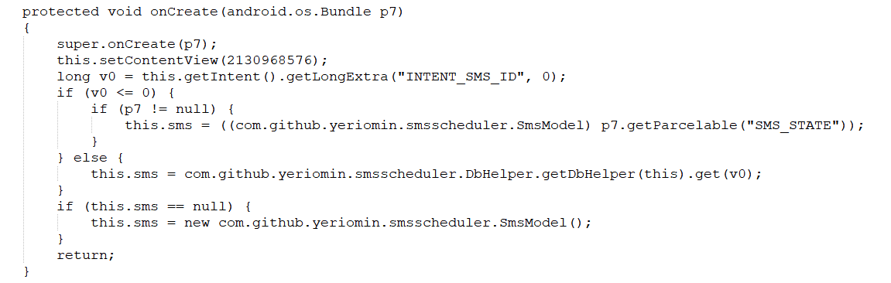

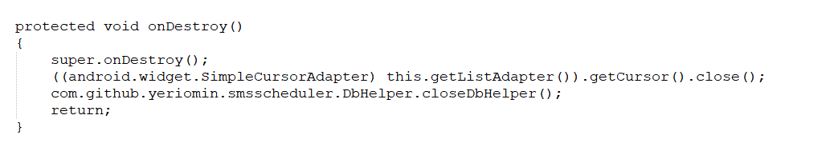

**For functional modules:**

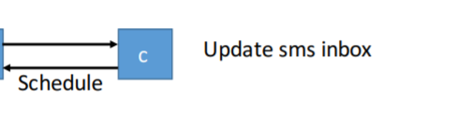

**The main function of this part is to update the SMS receiving box within a certain time gradient.**

**The corresponding key code in sample is:**

**The class C first inherits the** **broadcast receiver，Update the content of the short message by rewriting the onReceive callback function and send it to a fixed address**

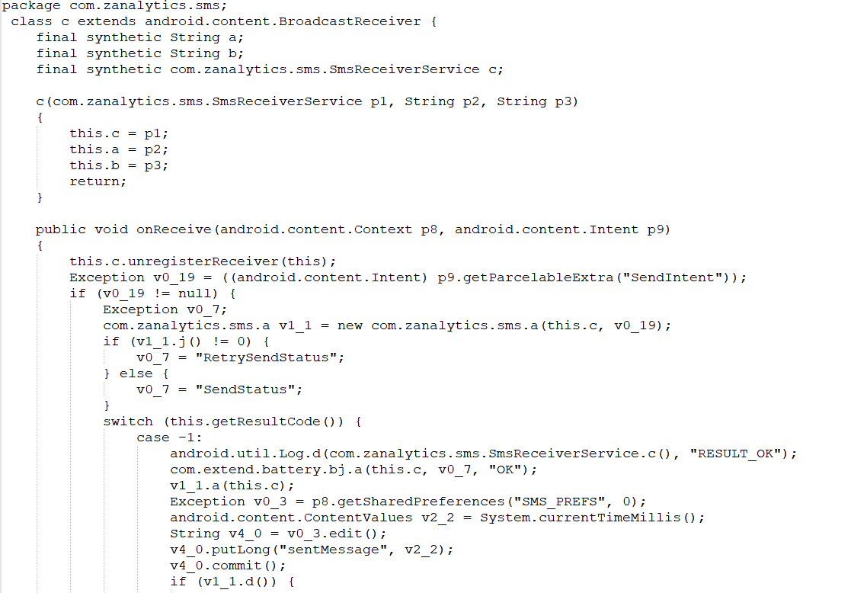

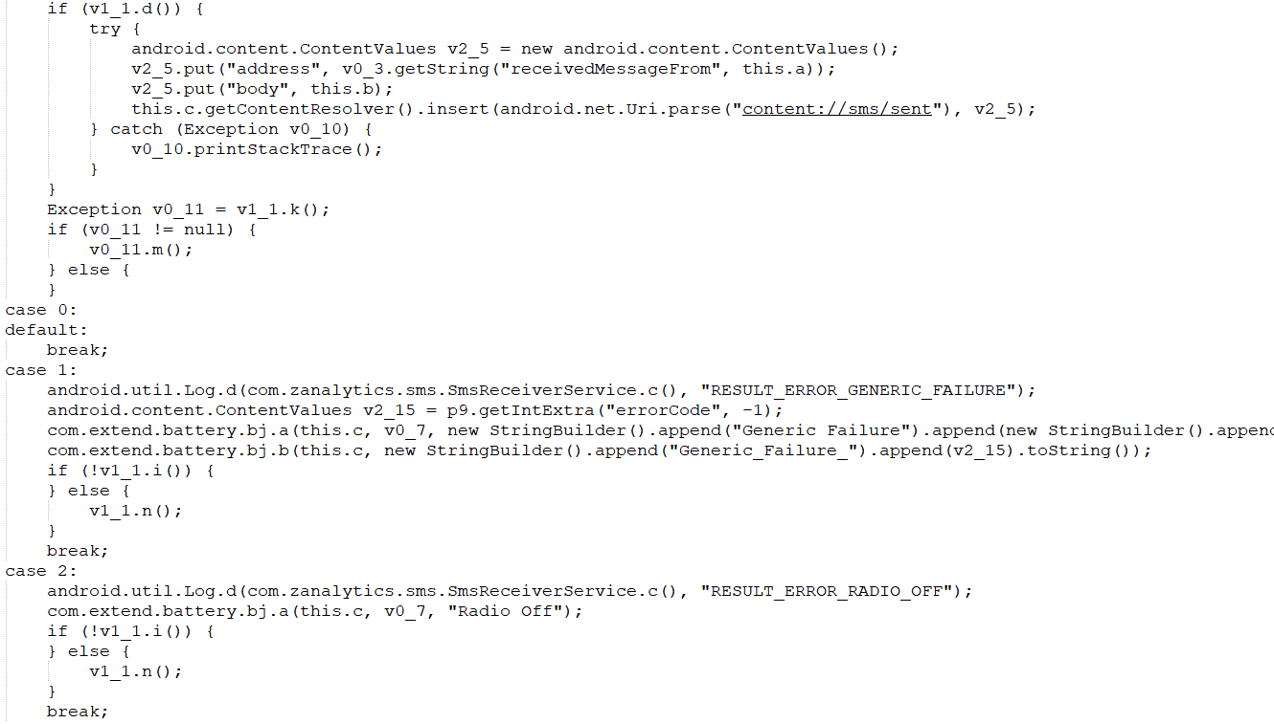

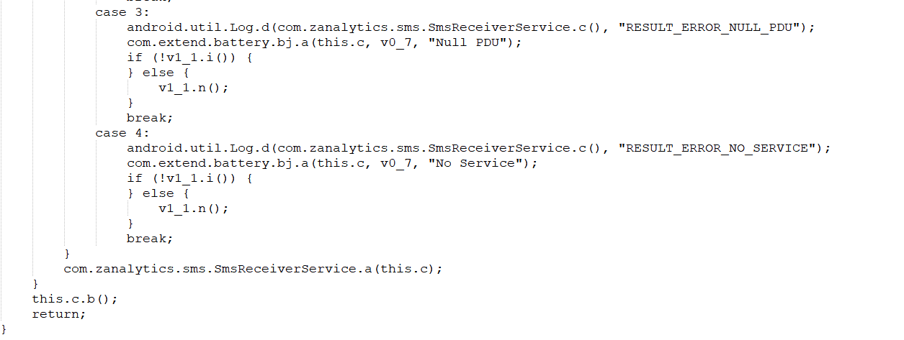

**Corresponding Functional Section Description**

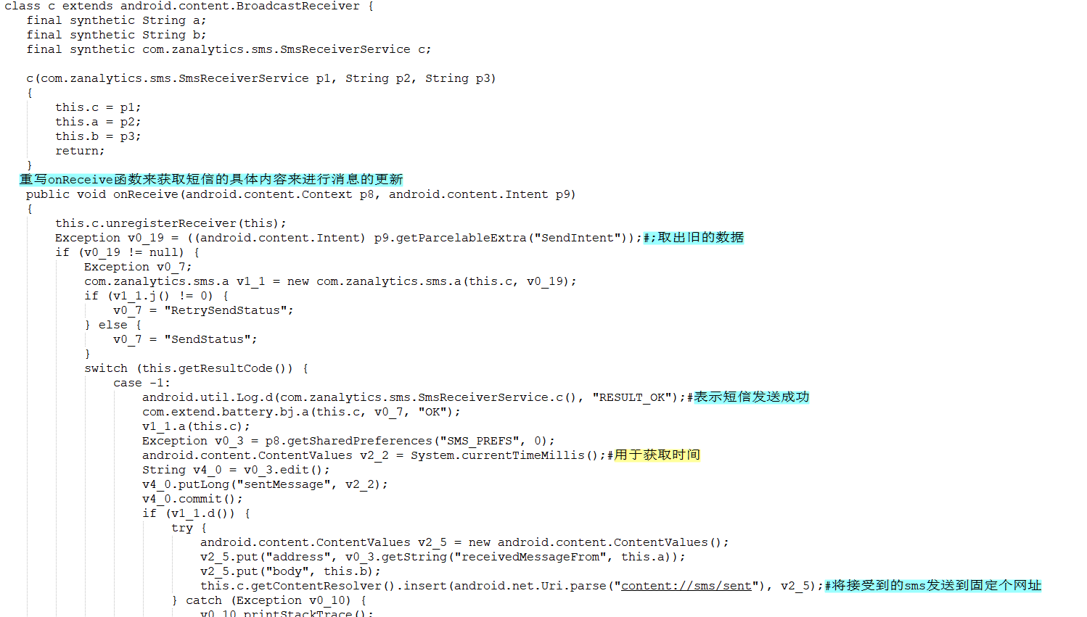

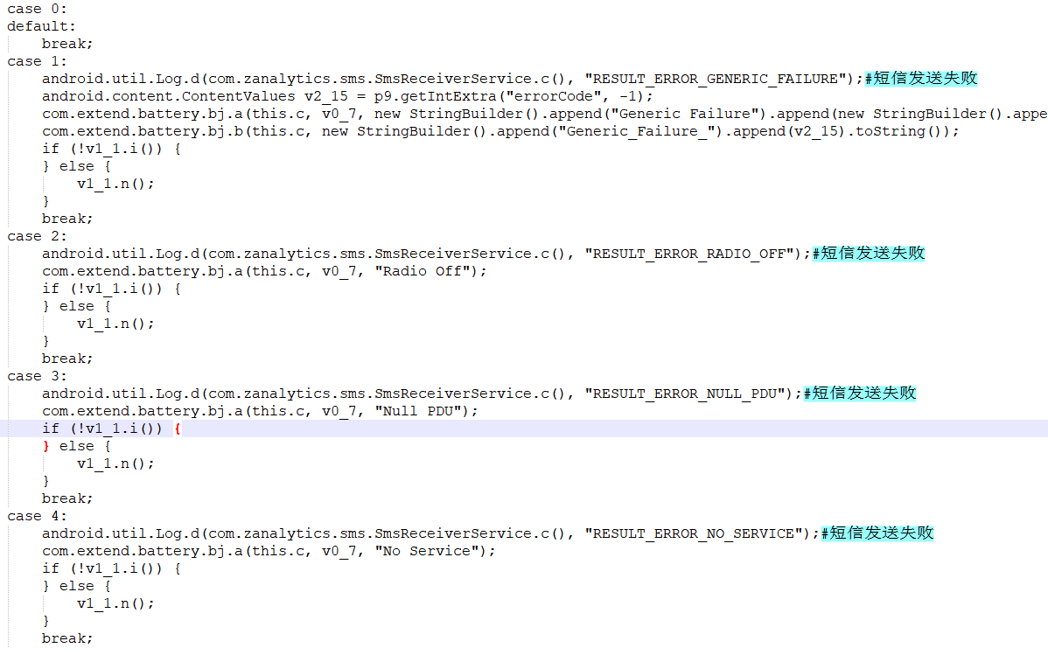

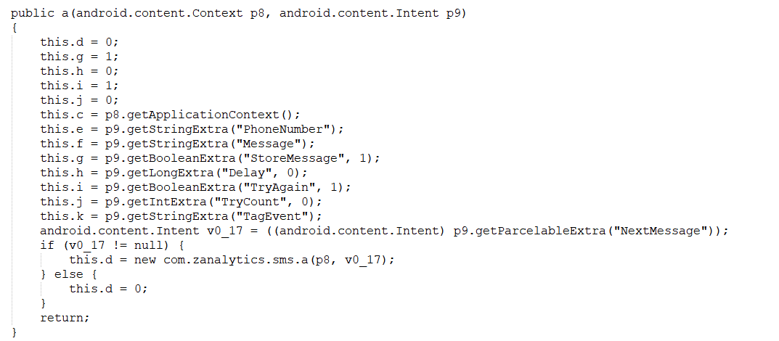

**Different processing for the sending status of short message in C.**

**Corresponding to the key code in this app:**

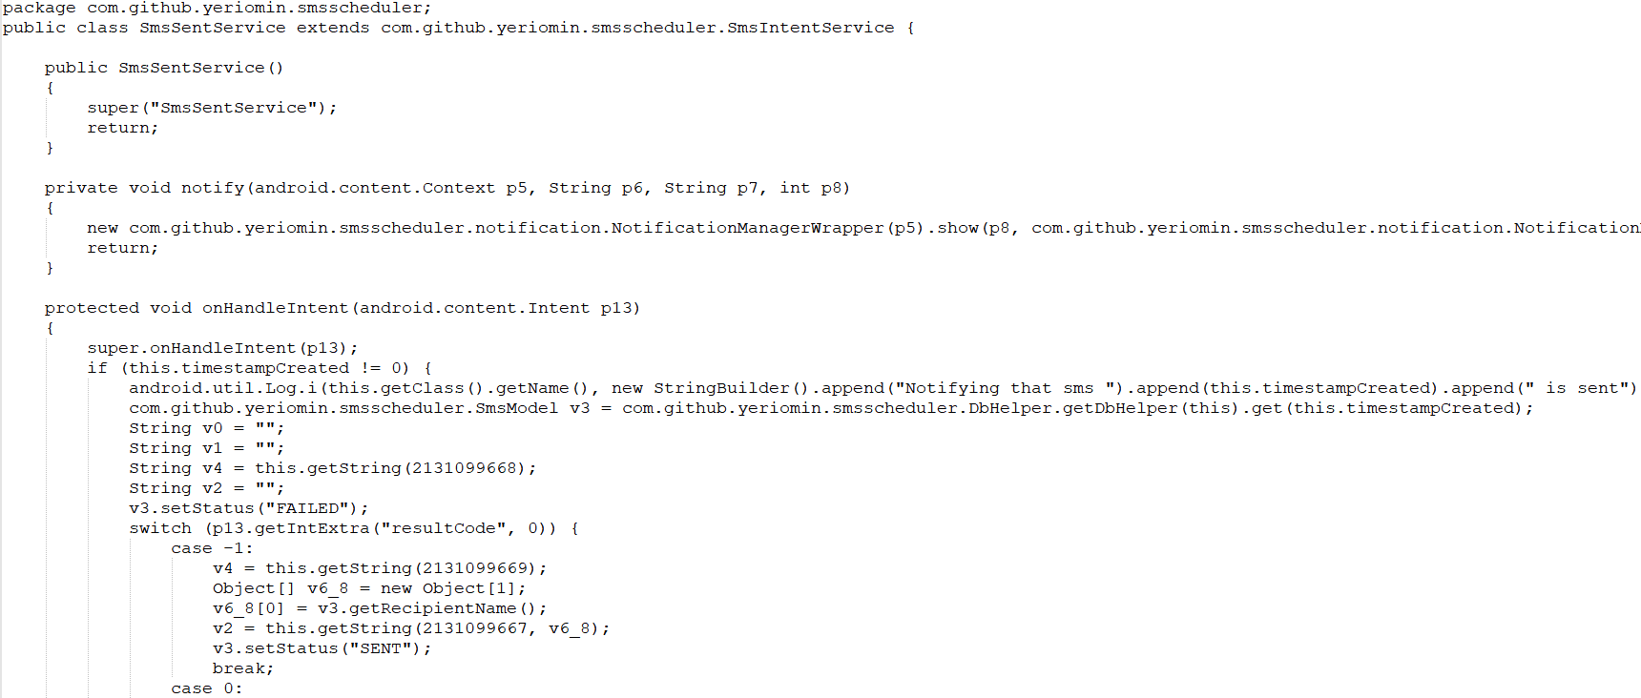

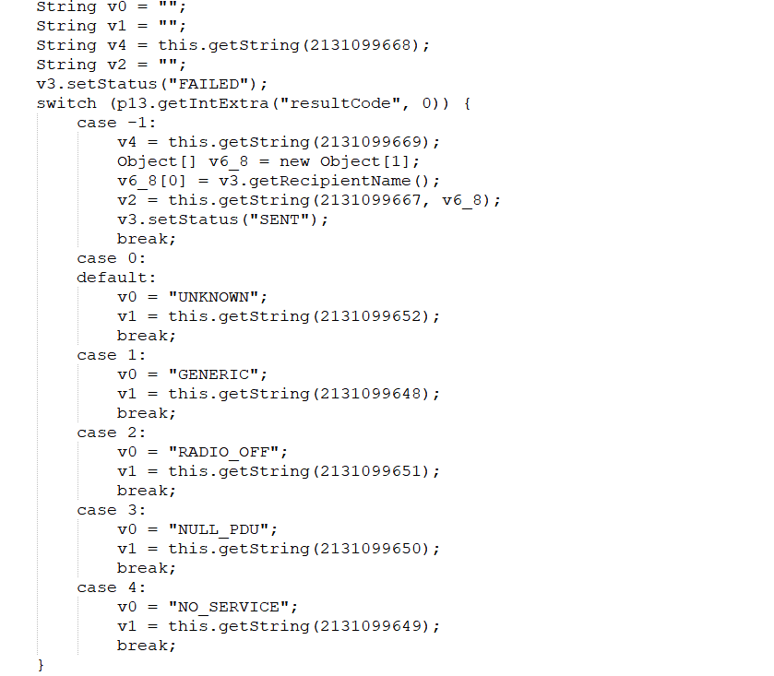

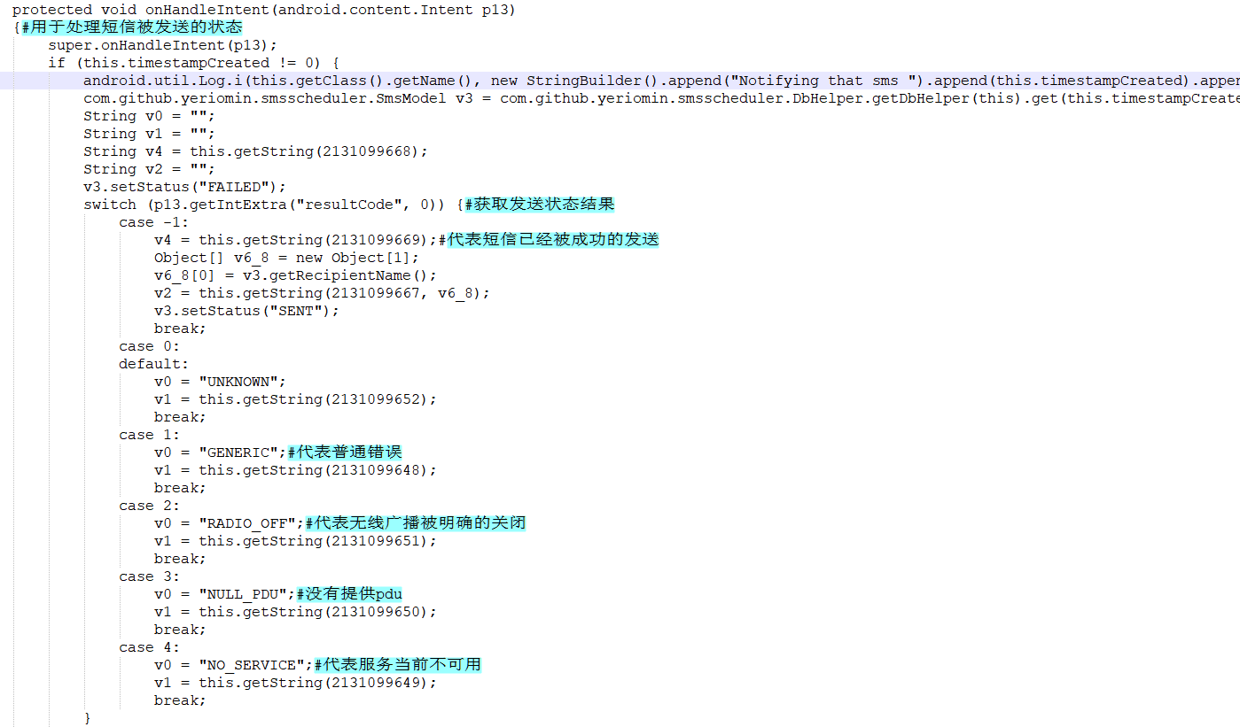 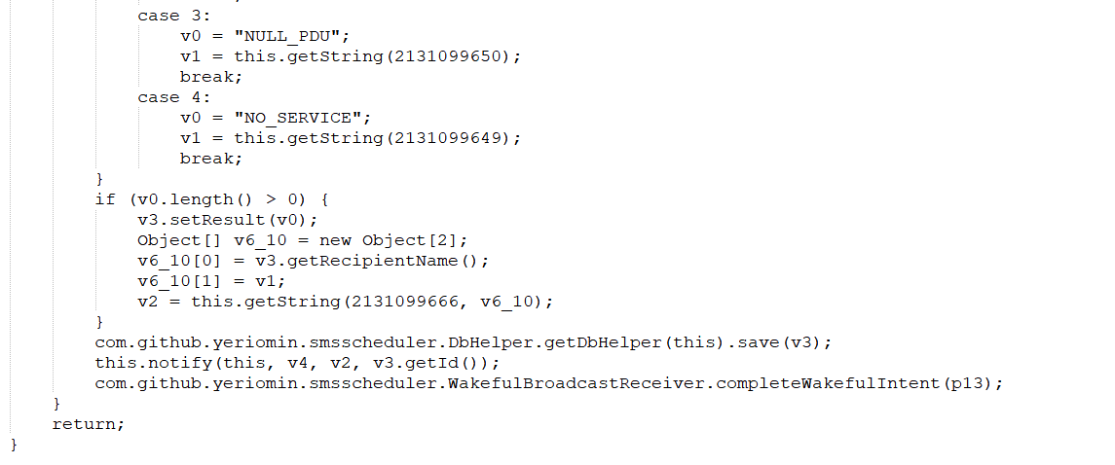

**For this function module, the corresponding functions of sample app and this app are related to the processing of the sending status of short messages. In sample app, the content of short messages is updated and sent to a fixed address. In this app, the processing of sending status of short messages is only normal.**

**Reasons for misidentification by stratification and non-division:**

**Because the corresponding callback function and the corresponding token keyword are similar, they are recognized as the pattern form.**